


Nom : COELHO FERNANDES

Master 2 SD Prénom : Rodrigo César

Machine Learning in Sequences

Séance de TP 1
Hidden Markov Models (HMM) are generative models

- Generate synthetic data with the trained HMM
  - Write a method that exploits the generative Hidden Markov Model property to generate synthetic digits images of size 28 x 28. The trained models are made available in a specific folder following the naming

def GenerateSamples(self, N_samples, length):
# Initialize arrays to store generated states and observations.
seq_states = np.zeros((N_samples, length,), dtype=int)
seq_observations = np.zeros((N_samples, length), dtype=int)

# Create a random number generator using numpy's default RNG
generator = np.random.default_rng()

Intervals_A = np.roll(np.cumsum(np.exp(self.log_A), axis=1), 1)
Intervals_A[:, 0] = 0 # Set the first column of Intervals_A to 0

Intervals_B = np.roll(np.cumsum(np.exp(self.log_B), axis=1), 1
Intervals_B[:, 0] = 0 # Set the first column of Intervals_B to 0

n = 0 # Sample counter

# Loop over the desired number of samples (N_samples)
while n < N_samples:
# Generate an array of random numbers for the state sequence.
draw_state = generator.random((length

# Loop over the time steps to generate the states.
for t in range(1, length - 1):
# Get the cumulative distribution (CDF) for the previous state
I = Intervals_A[seq_states[n, t - 1], :]
test = I[I < draw_state[t]]
seq_states[n, t] = np.size(test) - 1
if seq_states[n, length - 2] > self.n_states - 3:
seq_states[n, length - 1] = self.n_states - 1

# Generate observations based on the final states
draw_obs = generator.random((length,))
for t in range(length - 1):
I = Intervals_B[seq_states[n, t], :]
test = I[I < draw_obs[t]]
# Set the observation for this time step
seq_observations[n, t] = np.size(test) - 1
# Increment the sample counter
n += 1

# Return the generated sequences of states and observations
return seq_states, seq_observations

  - How do you find the quality of the generated samples?

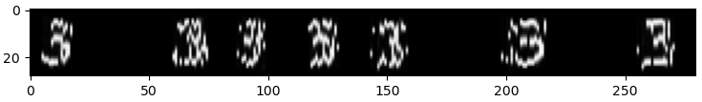
100_15

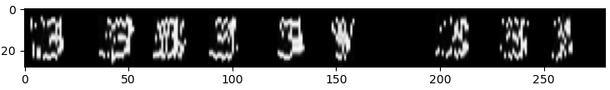
100_10

100_5
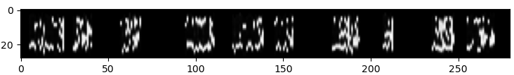

50_15
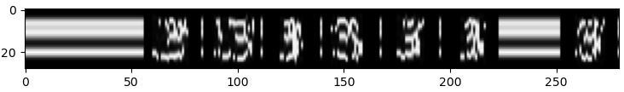
50_5

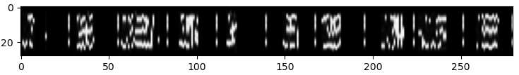
Podemos ver nas imagens das sequencias geradas que os exemplos com números de clusters e numeros de estados menores apresentam uma menor qualidade das amostras. Isso se traduz em representações com uma morfologia diferentes dos dígitos emperados, ou representaçoes incompletas ou fraturadas.
O aumento da quantidade de estados permite a modelagem de padrões mais complexos pelo modelo oculto, porém aparenta aumentar também a restrição da condição de geração, ocasionando a geração de vazios ou linhas horizontais contantes ao invés dos dígitos.

  - How would you qualify the imperfection of the generated data ?

  - What could be the reasons of the quality observed?

- Classify the synthetic data using Viterbi
  - Write a method that computes the log likelihood of the best hidden state path using the Viterbi algorithm, using the following interface.

def Viterbi(self,obs_seq):
T = obs_seq.shape[0]
Viterbi_lattice = np.zeros((T,self.n_states))
work_buffer = np.zeros(self.n_states)

Viterbi_lattice[0,:] = self.log_Pi + self.log_B[:,obs_seq[0]]
for t in range(1, T):
for j in range(self.n_states):
work_buffer = Viterbi_lattice[t-1, :] +self.log_A[:,j]
Viterbi_lattice[t,j] = np.max(work_buffer) +
self.log_B[j,obs_seq[t]]

Viterbi_lattice[T-1,:] += self.log_Pf

LL_best_path = np.max(Viterbi_lattice[T-1,:])

return LL_best_path

  - Then, compute the 10 log likelihood scores of the ten models for each generated observation sequence and vote for the best model that can be associated.

# Compute Loglikelihood of the best path with Viterbi
for c in range(N_classes):
LL_scores[c] = models[c].Viterbi(seq_observations[sample])

predicted_class = np.argmax(LL_scores)
print("\nLL_scores",LL_scores)
print("Classse:",classe,"meilleur model :",predicted_class,
"LL:",np.max(LL_scores))

Inserir resultados de previsões

  - Compute the Character Recognition Rate (CRR) and the Character Error Rate (CER) over the generated data.

if predicted_class == classe:
correct_characters += 1

# Aumente o número total de caracteres
total_characters += 1

# Verifique se a previsão da classe é incorreta para calcular o CER
if predicted_class != classe:
total_errors += 1

CRR = correct_characters / total_characters
CER = total_errors / total_characters

print(f"Character Recognition Rate (CRR): {CRR * 100:.2f}%")
print(f"Character Error Rate (CER): {CER * 100:.2f}%")

Character Recognition Rate (CRR): 86.00%
Character Error Rate (CER): 14.00%

- Classify the real data using Viterbi

  - Use the MNIST test dataset to test the recognition performance on the real data. Compute the CRR and the CER.

# Evaluate on MNIST test data
print("Evaluating on MNIST test data...")
true_labels = []
predicted_labels = []

total_test_characters = min(1000, len(X_test))
correct_test_characters = 0
total_test_errors = 0

LL_scores_test = np.zeros((N_classes,))

for i in tqdm(range(min(1000, len(X_test)))): # Limit to 1000 samples for faster testing
observation_sequence = X_test_discrete[i]
true_class = y_test[i]

# Compute log-likelihood for each class
for c in range(N_classes):
LL_scores_test[c] = models[c].Viterbi(observation_sequence)

predicted_class = np.argmax(LL_scores_test)

true_labels.append(true_class)
predicted_labels.append(predicted_class)

if predicted_class == true_class:
correct_test_characters += 1
else:
total_test_errors += 1

# Calculate CRR and CER for test data
CRR_test = correct_test_characters / total_test_characters
CER_test = total_test_errors / total_test_characters

print(f"\nMNIST Test Results:")
print(f"Character Recognition Rate (CRR): {CRR_test * 100:.2f}%")
print(f"Character Error Rate (CER): {CER_test * 100:.2f}%")

# Create confusion matrix
print("\nConfusion Matrix:")
cm = confusion_matrix(true_labels, predicted_labels)
print(cm)

# Plot confusion matrix
plt.figure(figsize=(10, 8))
sns.heatmap(cm, annot=True, fmt='d', cmap='Blues',
xticklabels=range(10), yticklabels=range(10))
plt.title('Confusion Matrix for MNIST Test Predictions')
plt.xlabel('Predicted Label')
plt.ylabel('True Label')
plt.tight_layout()
plt.savefig('confusion_matrix_mnist.png')
plt.show()

# Print classification report
print("\nClassification Report:")
print(classification_report(true_labels, predicted_labels, digits=4))

MNIST Test Dataset - Character Recognition Rate (CRR): 11.35%
MNIST Test Dataset - Character Error Rate (CER): 88.65%

  - Is Viterbi a good classification method ?

Based on the experimental results obtained from both synthetic and real MNIST test data, the Viterbi algorithm demonstrates strong performance as a classification method for digit recognition using Hidden Markov Models (HMMs), but modern deep learning approaches may achieve higher accuracy rates.
Also, Viterbi's performance is heavily dependent on the quality of the underlying HMM parameters. Poorly trained models will yield suboptimal classification regardless of the decoding algorithm.

Sabendo que este é o inicio do codigo, voece saberia me explicar o que significam os valores de n_clusters e n_states ? Sei que eles sao usados para definir os arquivos (codebook e model) a serem carregados, mas nao sei qual a deferença entre as versoes destes arquivos.
Percebi também que para valores mais baixos de n_clusters as imagens geradas pela funçao GenerateSamples apresentam mais ruido e deformaçao, porém n_samples maiores muitas vezes geram imagens em branco. Enquanto que as imagens geradas por valores menores de n_states por vezes apresentam linhas horizontais ao invés das imagens experadas.

Those were my results for this code :
On generated data :
Character Recognition Rate (CRR): 86.00%
Character Error Rate (CER): 14.00%

MNIST Test Results:
Character Recognition Rate (CRR): 89.50%
Character Error Rate (CER): 10.50%

Answer the following for the conclusion of a academic report: Is Viterbi a good classification method ?

